HANA tables import method 2

1. Right click your User name”GBI_XXX”, Create a new Table.

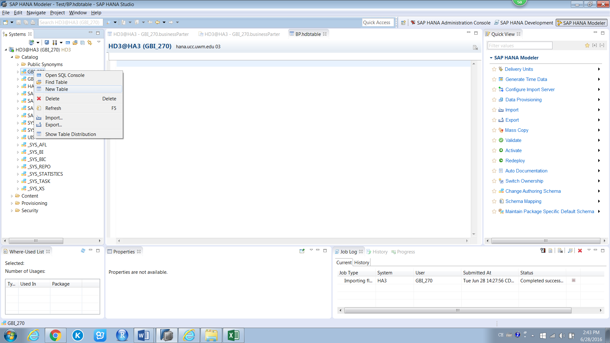

1. Input all the Column name, value dimension and select the correct data type according to the data set. Click the “Key” area to set the key to Primary Key.

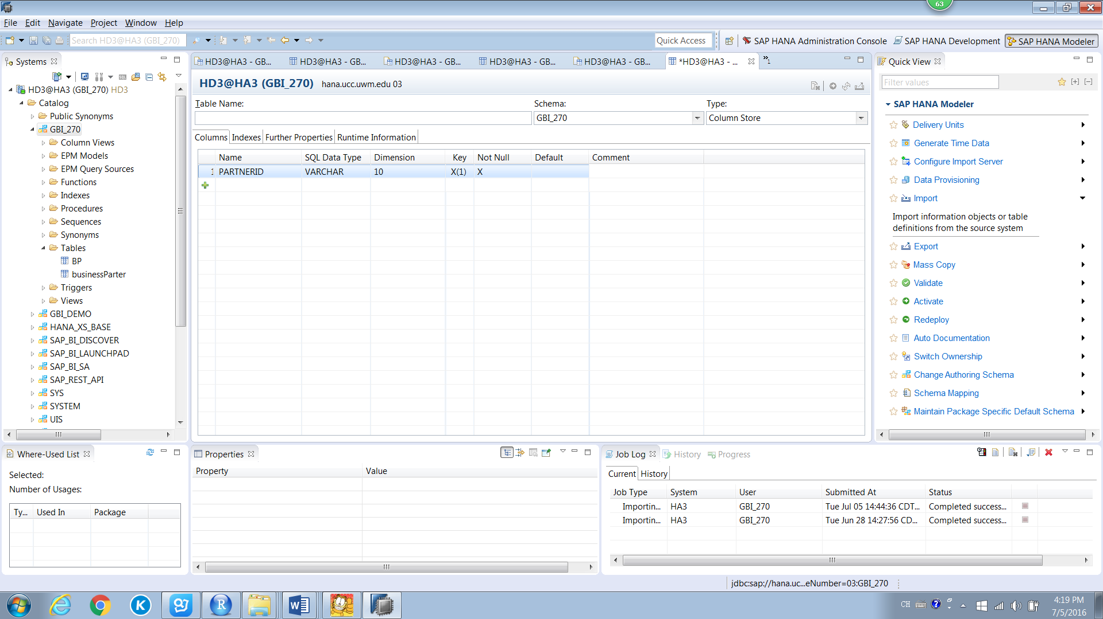

1. Click “File” then Click “Import”, in the dialog it comes out open “SAP HANA Content” then click Data from Local File.

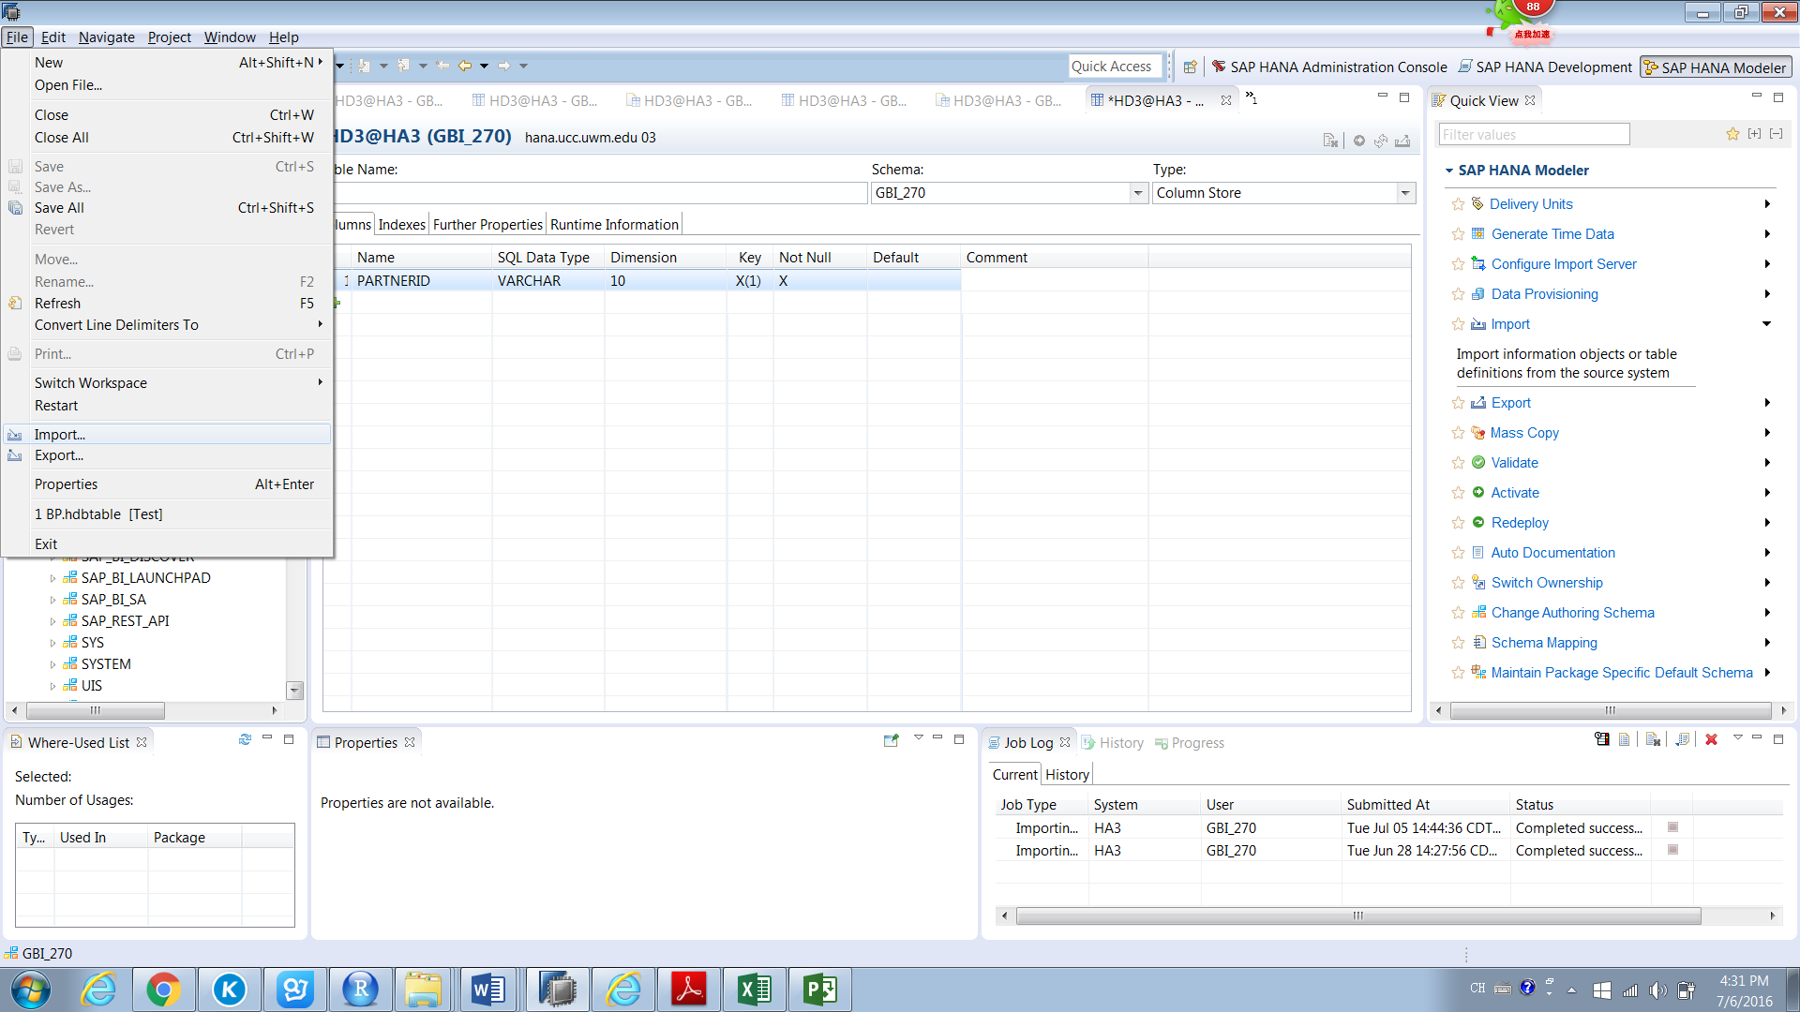

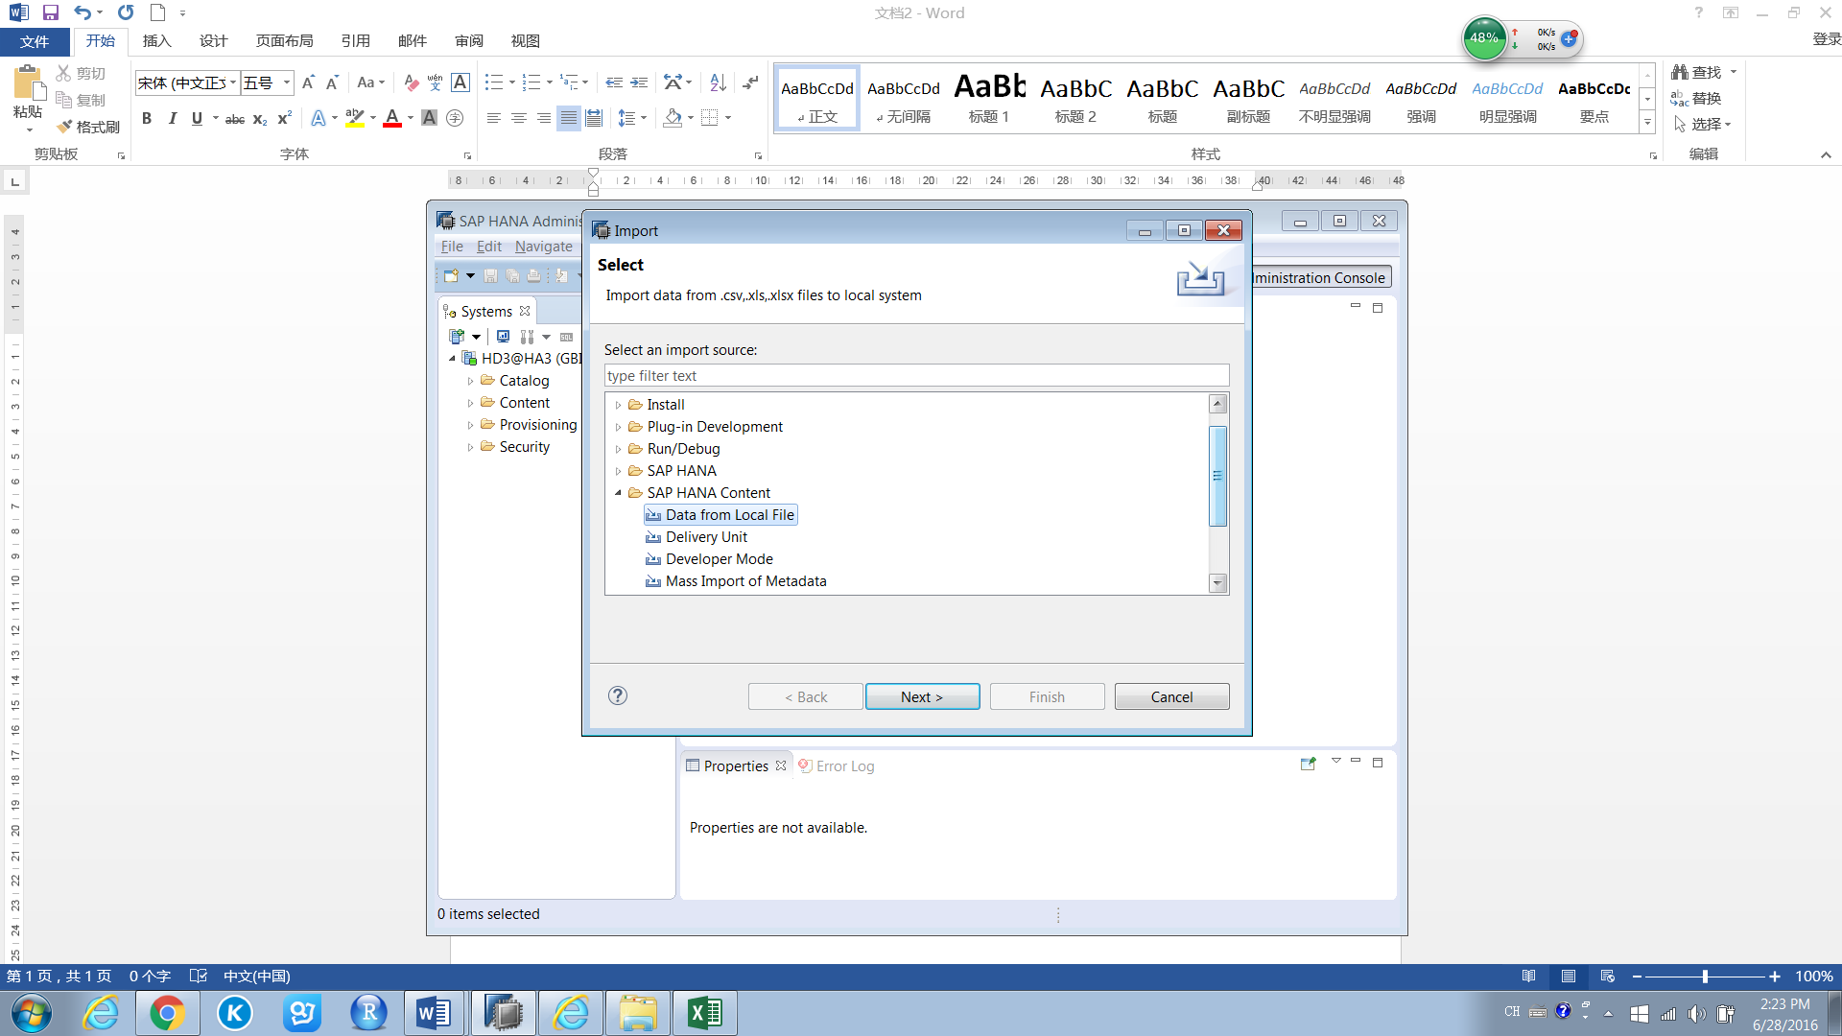

1. Choose the system then click Next

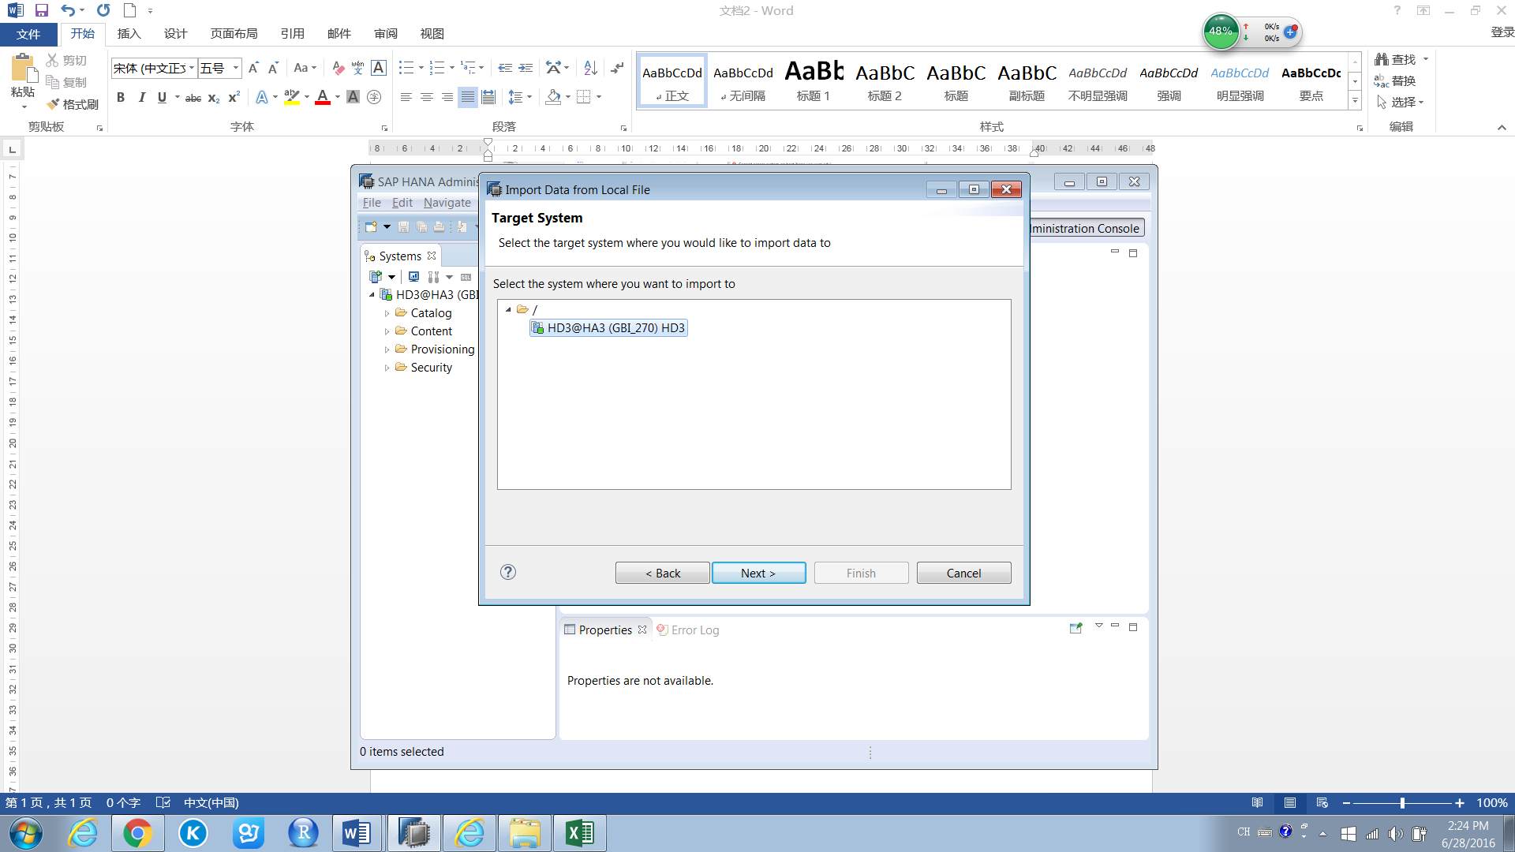

1. Click Browse to choose the data file. Click the check box of “Header row exists”, “Import all data” and “Ignore leading and trailing white-space(s) in file”

For target table, select Exiting then select the table you just created.

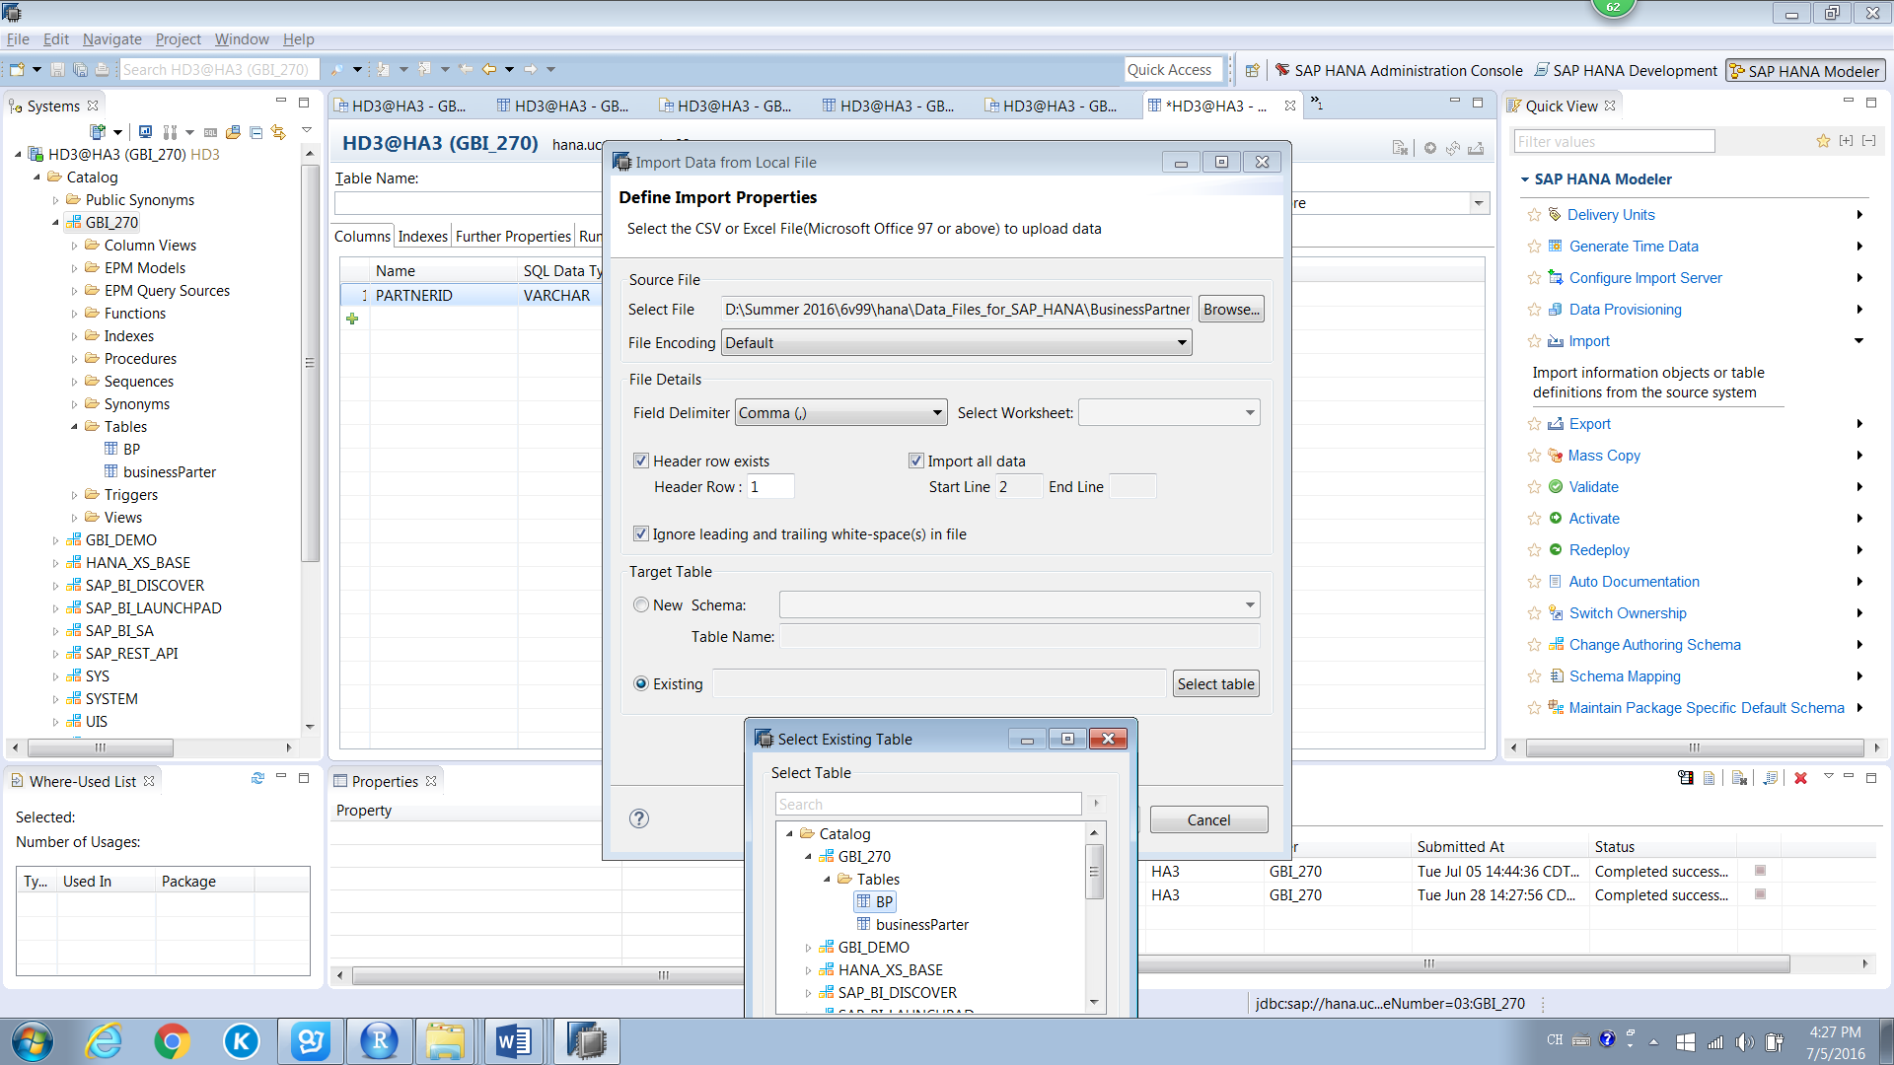

1. Pull the key in the left box of Source File to the key in the right of Target Table to connect, then the data of the key in data source will import to the key you created

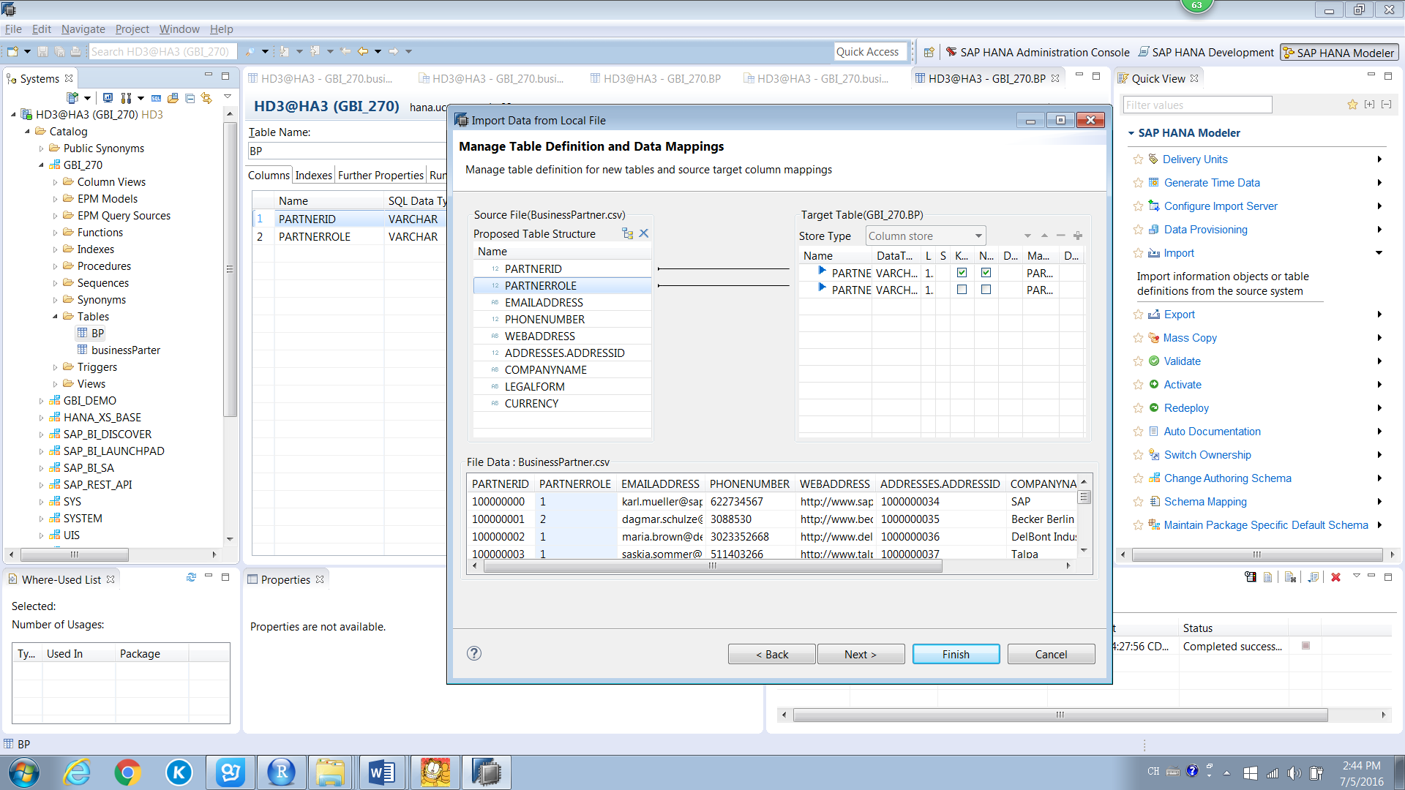

1. Click finish then you will see the data imported to the table you created.

